# Project Plan

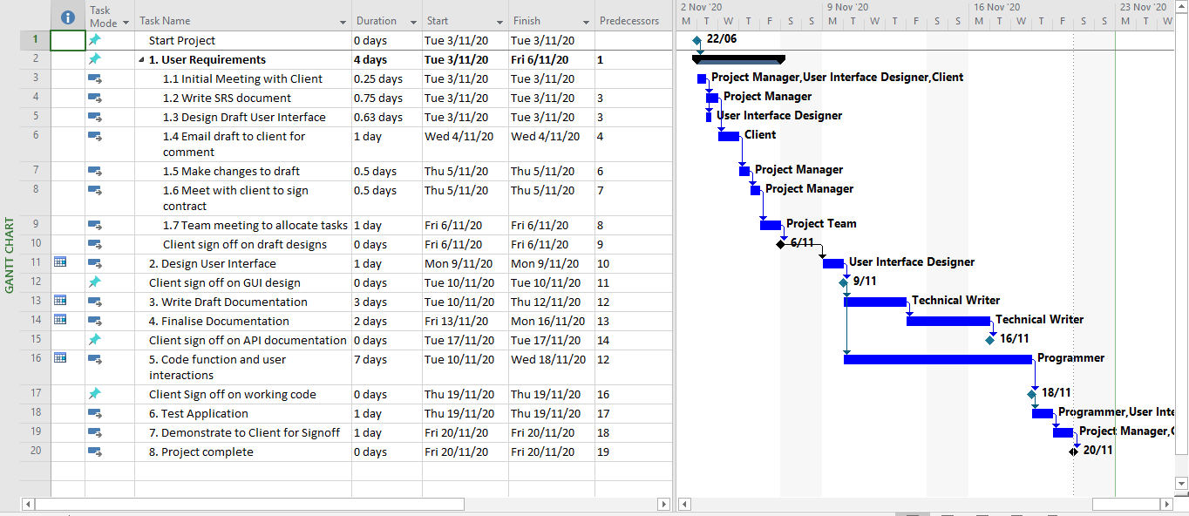

Figure Updated project plan to include additional milestones

Updated Project plan developed using MS Project

# Source Control

The source control can be found at:

<https://github.com/Jely101/Software-Deployment>

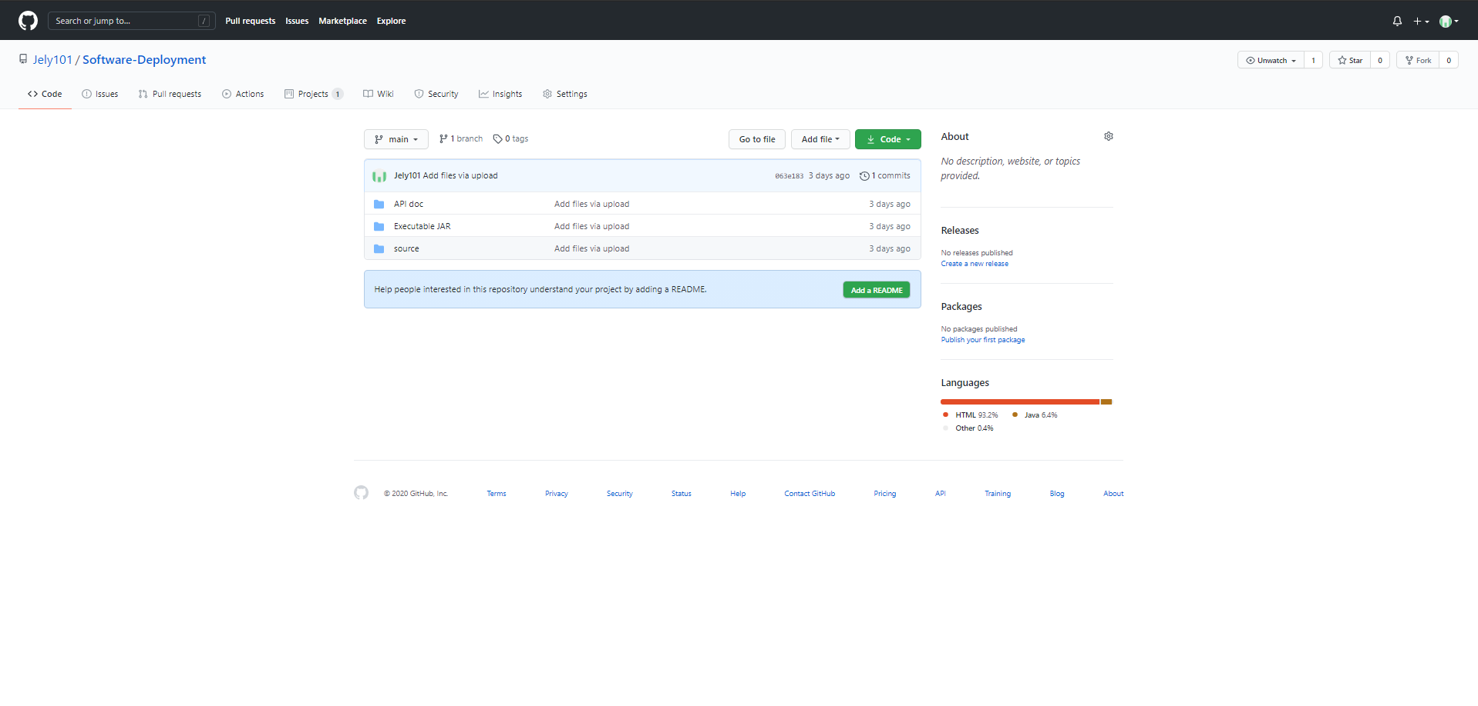

Figure Source Control snapshot

# Collaboration

The Collaboration environment can be found at:

<https://github.com/Jely101/Software-Deployment/projects/1>

